Hi, I’m Duane of AnyoneCanFixIt.com. I like looking at new technologies that anyone can implement to save money. One of the things I have recently investigated and implemented in my own house is LED lighting. I’ve been waiting for the technology to develop and the price to become feasible to implement this technology. I think that time has arrived.

I have a lot of dimmer switches in my house, in fact, they are electronic light controllers made by Insteon …I N S T E O N which you can get from Smarthome.com. These switches allow me to control various lights from one location in the house or even implement controlling them remotely from the internet. When LEDs first came out, they were not compatible with dimmers. Today, though, there are LEDs that will work with dimmers.

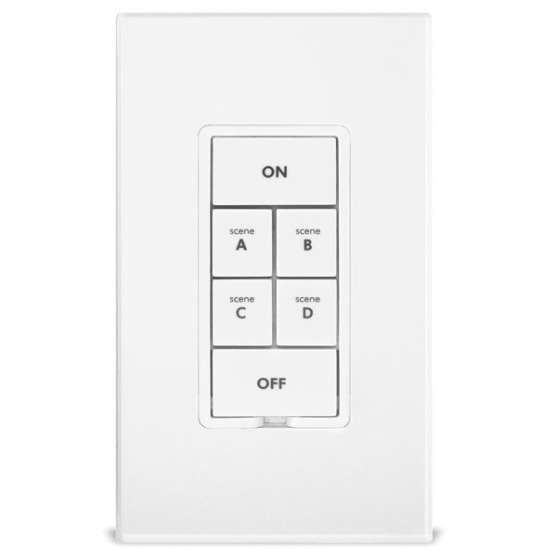

I’ve got a variety of lights…recessed lights, overhead lights, lights in the ceiling fans, decorative lights above the bathroom mirror, and desk lamps…to name a few. I’ve found LED lights that fit and work in all these applications.

What is efficient about LED lights is that they provide the same amount of light as your regular candescent light bulbs for about 84% less energy. The light that is normally delivered by a 60W incandescent light bulb can now be supplied by a 9.5W LED light bulb…and you will be hard pressed to see the difference in lighting (with the right choice in LED lighting). So, if you have a light fixture that has 4 lights, like this bathroom fixture, using four 60W bulbs, you can replace those with 9.5W LED bulbs and go from using 240W while burning them to using only 38W. That’s a pretty significant savings…especially when you start looking around and realize how many multiple bulbs you may have lighting your house.

There were two things that convinced me it was time to switch to LED lights. The first was the price. Cree has come out with a 60W bulb that is about $13 from Home Depot. Not only is it about $13, but it’s GUARANTEED for 10 years! (actually their rated life is 22.8 years based on 3 hrs/day usage). And the other thing, they are compatible with dimmers.

The Cree lights come in two different Types of light. WARM WHITE and DAYLIGHT. You want to stick to the WARM WHITE bulbs (which have a rating of about 2700K light appearance) They have a DAYLIGHT bulb that is rated at 5000K light, but these lights provide a very white, sterile light…like you’d find in an operating room. If you are looking for something that is equivalent to a soft white 60W incandescent bulb, stick with something rated at about 2700K. A Home Depot employee reported to me that about 80% of the Daylight versions are returned because they are too bright. So, I’m here to tell you for an incandescent replacement, get the WARM WHITE bulb.

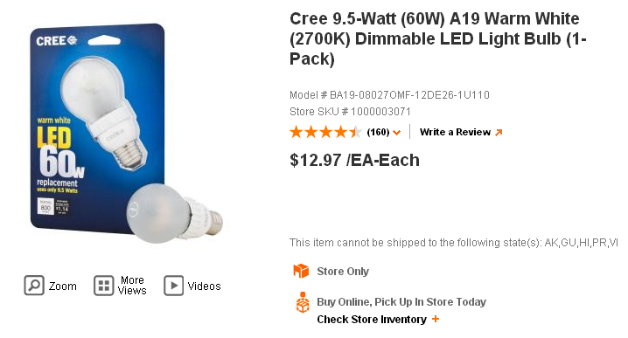

The Cree bulbs look like a regular incandescent shaped bulb and have a rubber safety coating around the bulb, but appearance-wise they look like a regular bulb. They are designed with LED lights pointing out to the sides of the bulb. That can make a slight difference in how one of these bulbs will illuminate versus a standard incandescent. It tends to shine the light the brightest from the sides of the bulb. I found one of the applications this works well in is a night stand lamp application.

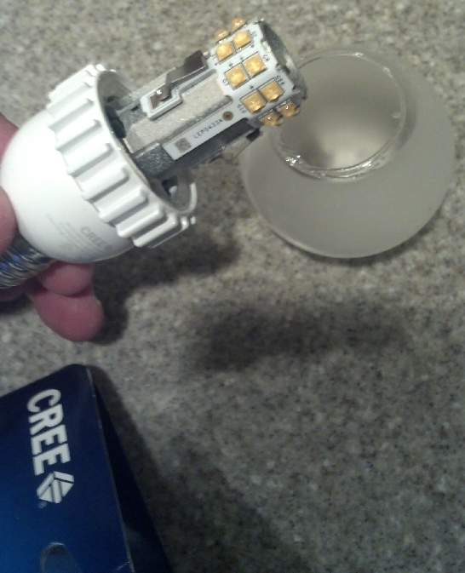

The other bulb I tried was a Home Depot Ecosmart 40W Bright White bulb. These bulbs can be found at Home Depot for about $10 each. This bulb actually uses 6Watts to get the 40W incandescent bulb amount of light. This bulb has a light Appearance rating of 3000K, which is close to the 2700K of the Cree WARM WHITE BULB. If you are about 2700K-3000K, the light will be very close to a standard incandescent bulb. This bulb too is dimmable. It doesn’t carry the 10 year warranty that the Cree does, but it’s rated life is 22.8 years also and only has a 5 year warranty. One of the big difference between this and the Cree bulb is the orientation of the LED providing the light. The LEDs on this Ecosmart bulb are directing light out the top of the bulb. Where I have found that these lights are used best is for desk lamps. They are good to direct the light to straight out of the top of the bulb.

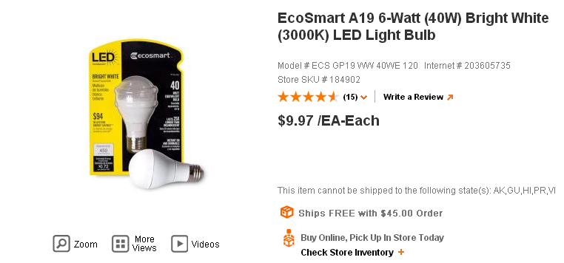

Between the Ecosmart and the Cree bulbs, I found that both dim, but with most LED bulbs, they don’t dim really, really low, though. They’ll turn off before getting to the dimly lit glowing level. The Ecosmart did best at getting to the lowest light level when being dimmed (but then again, the Ecosmart is a 40W and the Cree is a 60W). The Cree isn’t too far behind.

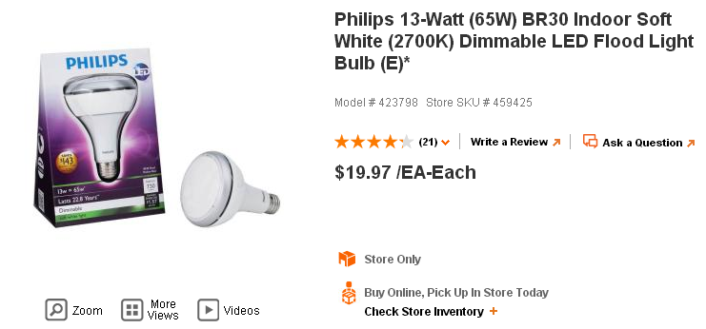
The next bulb I found for my recessed lighting application was a Philips 65W equivalent LED dimmable Soft White bulb (with a BR30 Flood Medium Base). This fit my 5 inch diameter opening recessed lights. These provide a great equivalent light to the incandescent bulbs that they were replacing. They had a 2700K Appearance Rating. Their cost is quite a bit higher at $19.99 which was a sale price I got them for at Home Depot. They do have a slight delay when being turned on (about ¼ second)…hardly noticeable unless you compare them to one of the other LED lights…I have a Phillips LED light in the spot light in this scene and Cree lights in the recessed lighting of the cabinets. You can see when I turn on the lights, there is about a ¼ second delay in turning on the Philips spot light. You won’t really even notice this unless you have an application light this where a single switch turns on both two different types of bulbs (like the Philips and Cree mix in this video).

Also, the Philips bulb is the worst at dimming to a low level. It just doesn’t want to go to a very low, low light level before it turns off. It does dim, but just not to a barely visible glow level like you can achieve with an incandescent bulb.

The Philips bulb has an estimated life of 22.8 years when used for 3 hrs/day. The warranty is for 6 years. It provides 65W of incandescent light for 13W.

What I did in my house was replace all the lights in my house that I use about 90% of the time. There were a few lights I left as incandescent because we rarely use them (like in our formal dining room)…I figured I would wait a little longer since we don’t use them enough to justify buying their LED replacements (For the dining room, there would be 8 bulbs to replace in that fixture….we just don’t use it that much).

What I found in the couple of months that I have been using the LED bulbs, for the months of May and June, I have achieved a 10% savings in electricity usage.

In my comparison of May 2013, it didn’t compare well to May of 2012 because the temperature in May 2012 was quite a bit higher, so I compared it with another time period in which the average temperature was about the same. I found a time in October 2011 that had a similar average temperature. Comparing the two, May 2013 with the LED lights in use was approximately 9.4% lower in KWh usage.

Date Mailed | # Of Days | kWh Usage | Daily kWh Avg. | Avg. Daily Low | Avg. Daily High | Avg. Temp.
5/29/2013 | 32 | 1,742 | 54 | 56 | 73 | 65
10/27/2011 | 30 | 1,922 | 64 | 53 | 74 | 63

In my comparison of June 2013 to June of 2012, the temperatures were practically the same, so this compared well. I found that in June 2013 with the LED lights in use was approximately 10.3% lower in KWh usage.

Date Mailed | # Of Days | kWh Usage | Daily kWh Avg. | Avg. Daily Low | Avg. Daily High | Avg. Temp.
6/27/2013 | 29 | 2159 | 74 | 66 | 84 | 75
6/28/2012 | 29 | 2407 | 83 | 63 | 85 | 74

Thus, I believe it’s safe to say that I’m getting about a 10% savings from switching to the LED lights.

Now your usage may vary. It depends on how much you use your lights in your house, how many lights you have, and can vary depending on how much electricity is being used by air conditioning (one of the larger consumer of electricity in your house). You won’t get 10% savings in July/Aug when the majority of your energy bill will be from the use of the air conditioner (if you are using an air conditioner). But what I found in my usage, with this 10% saving in electricity from the switch to these LED, these bulbs will actually pay for themselves in the savings that they provide in about 2 years.

For example, my 2013 June Electric bill was $224.60. If this was 90% of what I would have been paying, then without the bulbs, I would be paying $249.56. A cost savings of $24.96 per month. See the calculations:

$224.60 90
$ X = 100

X= $249.56 Electric Bill without the LED lights

SAVINGS = $249.56 - $224.60 = $24.96/Month

Cost spent on Bulbs = $550 (this is approximately what I spent to replace the majority of the incandescent bulbs in my house).

Cost / Savings Per Month = Time to Repay Cost of Bulbs with Amount Saved by Bulbs = $550/$24.96 = 22 months approximately (just round to 2 years = 24 months)

The other benefit is if they actually last as long as they claim, I won’t be changing light bulbs as often as I was before. For whatever reason, it seemed like I was always replacing the recessed lighting bulbs and bulbs in my overhead fan light…a lot of this can be attributed to the fact that the incandescent bulbs are sensitive to vibrations and the ceiling fans provides a lot of vibration that reduce the life of an incandescent bulb….I should not have this problem with LED bulbs.

I hope you have found this information helpful and informative. Go to AnyoneCanFixIt.com to find other ways that Anyone Can Fix It and save yourself money.

